This document should be used as a basis on what the Robo Ice Cream should be and should be only considered the minimum. There may be other additions in the near future. I will do my best to split the information below into 2 parts. Hardware and Software.

## Hardware

**The Dispensing Robot**

There should be leds inside the Robots Head

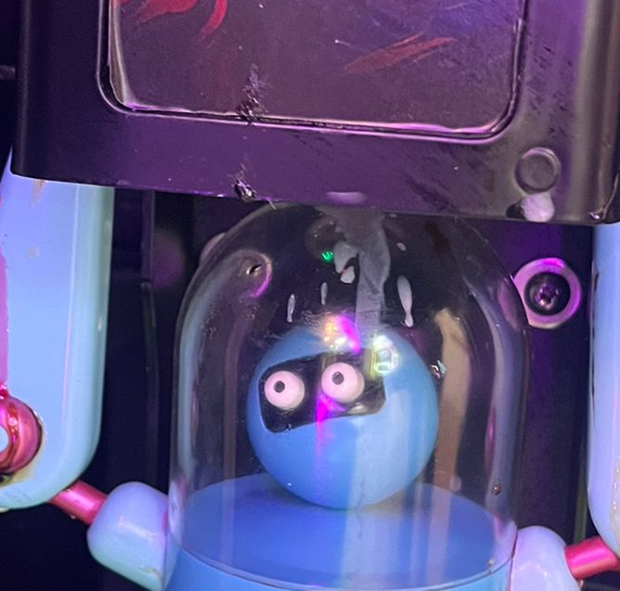

**Capacity to produce more than one flavor of ice cream**

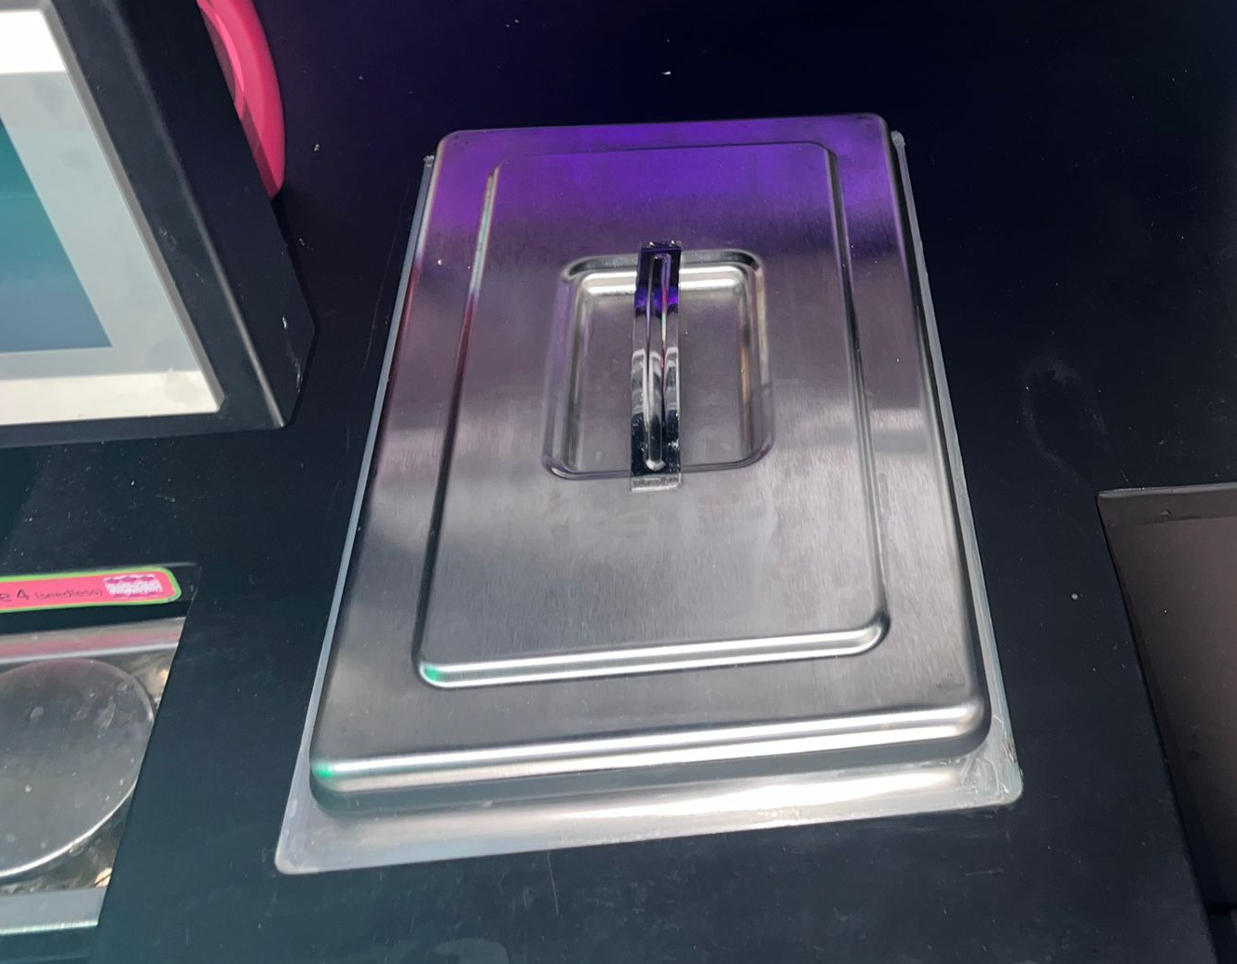

**Make screen more firmly attached; currently balanced on brackets**

Current Screen is held on by brackets and is easily pushed in. This needs to be avoided at all cost and the screen should be held in place securely.

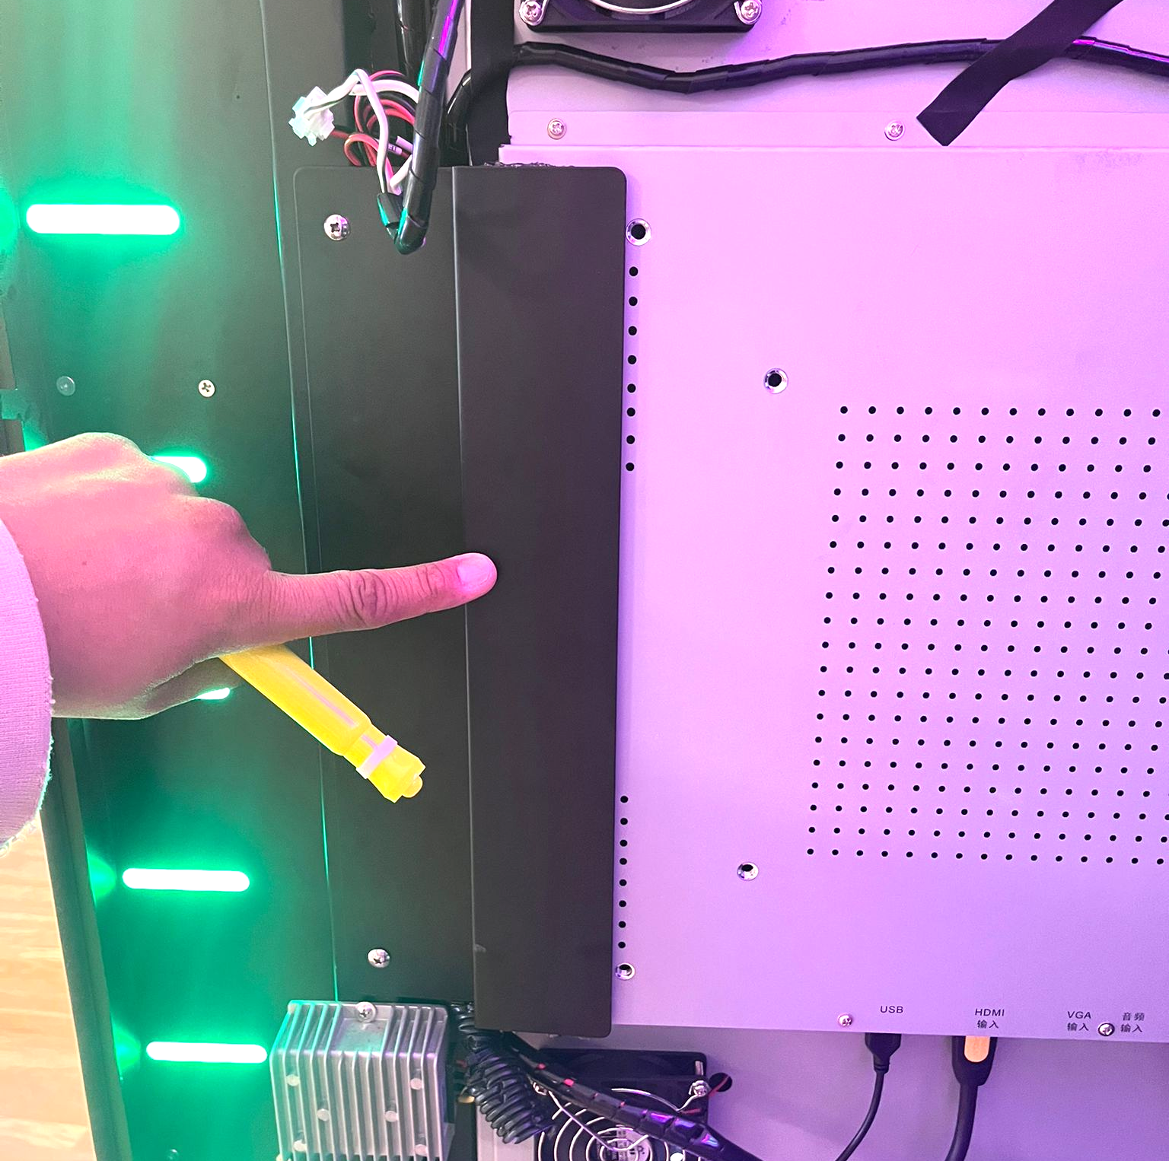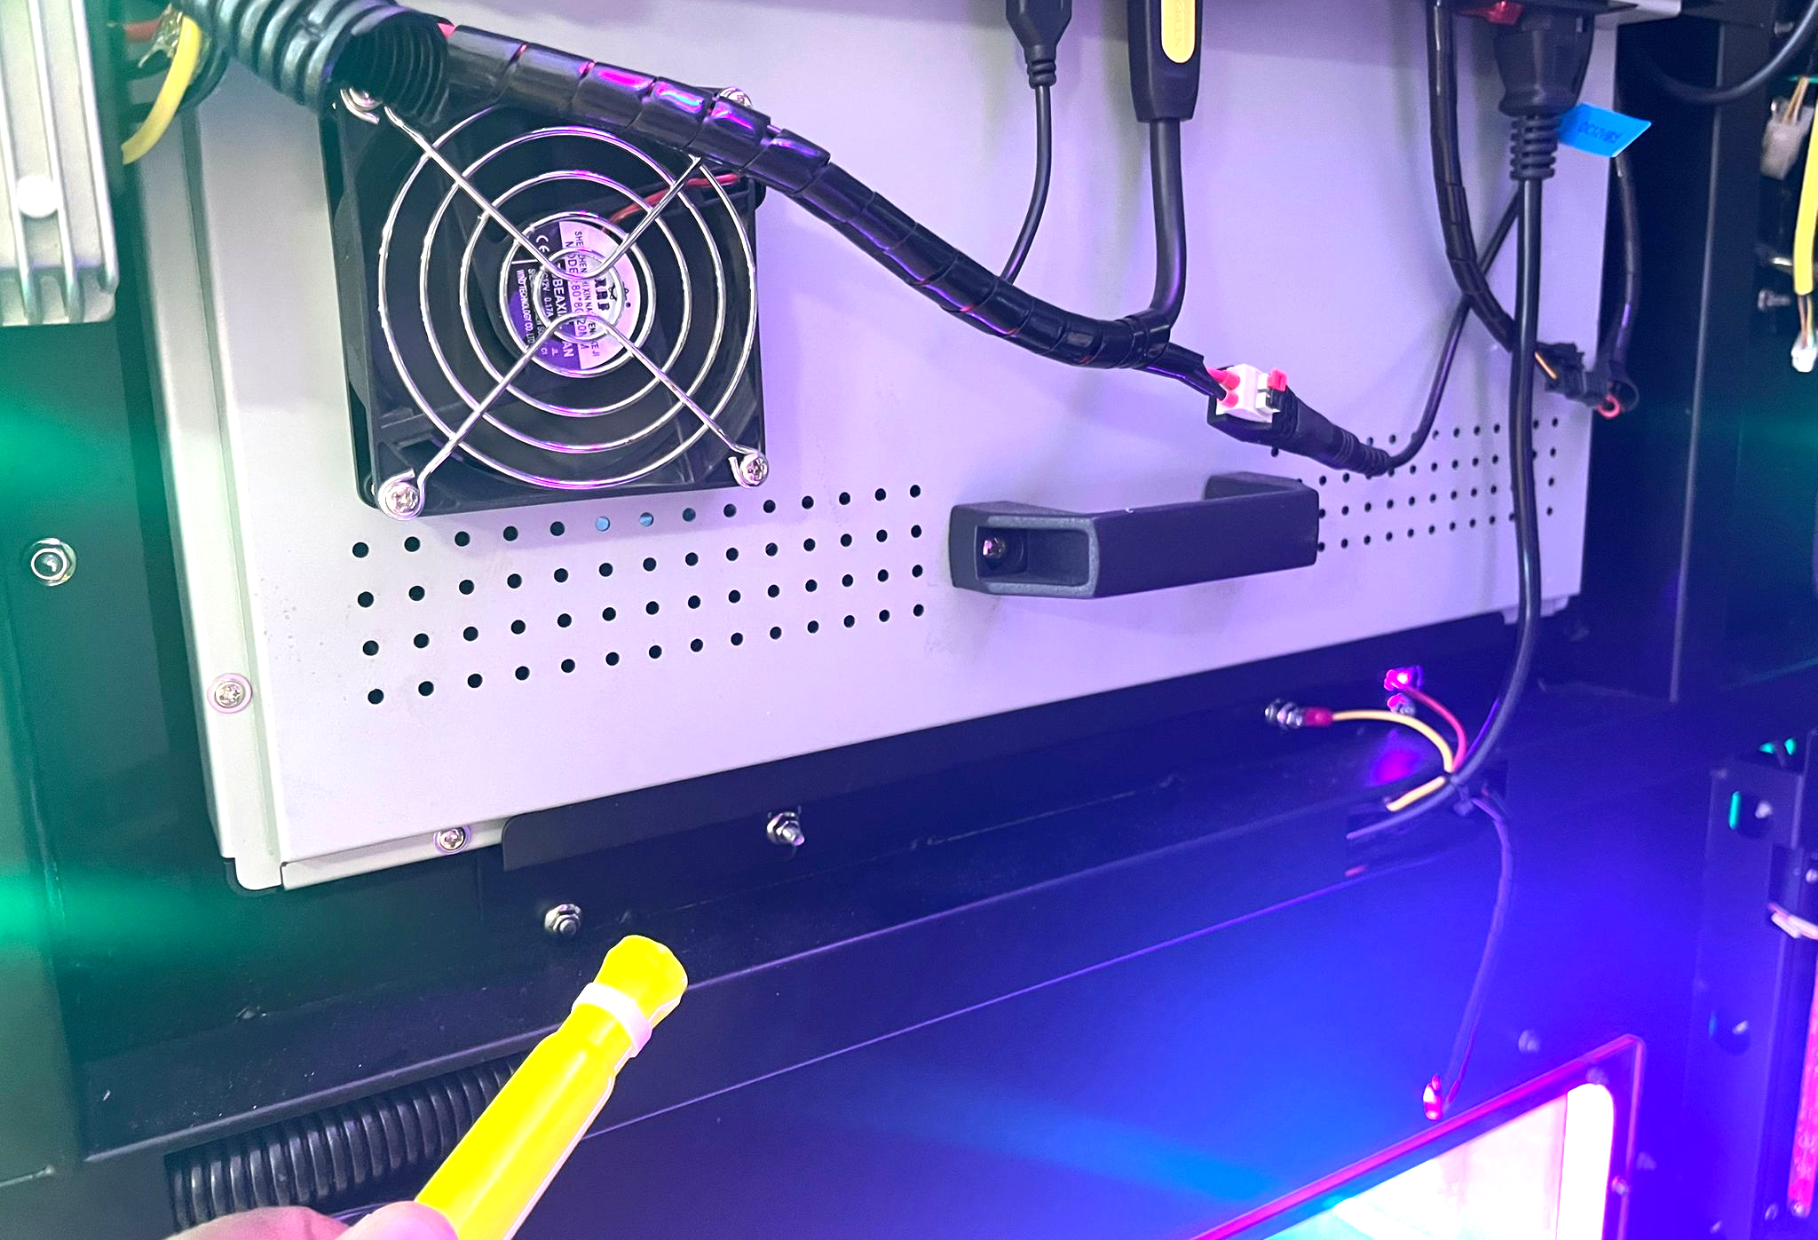

**Increase distance between syrup nozzles for better distributors**

The actual nozzles for the machine are too close and this makes it difficult to create a spreader for the syrup distributor. They need to be spaced out further to allow bigger distributors for more coverage over the ice cream cup.

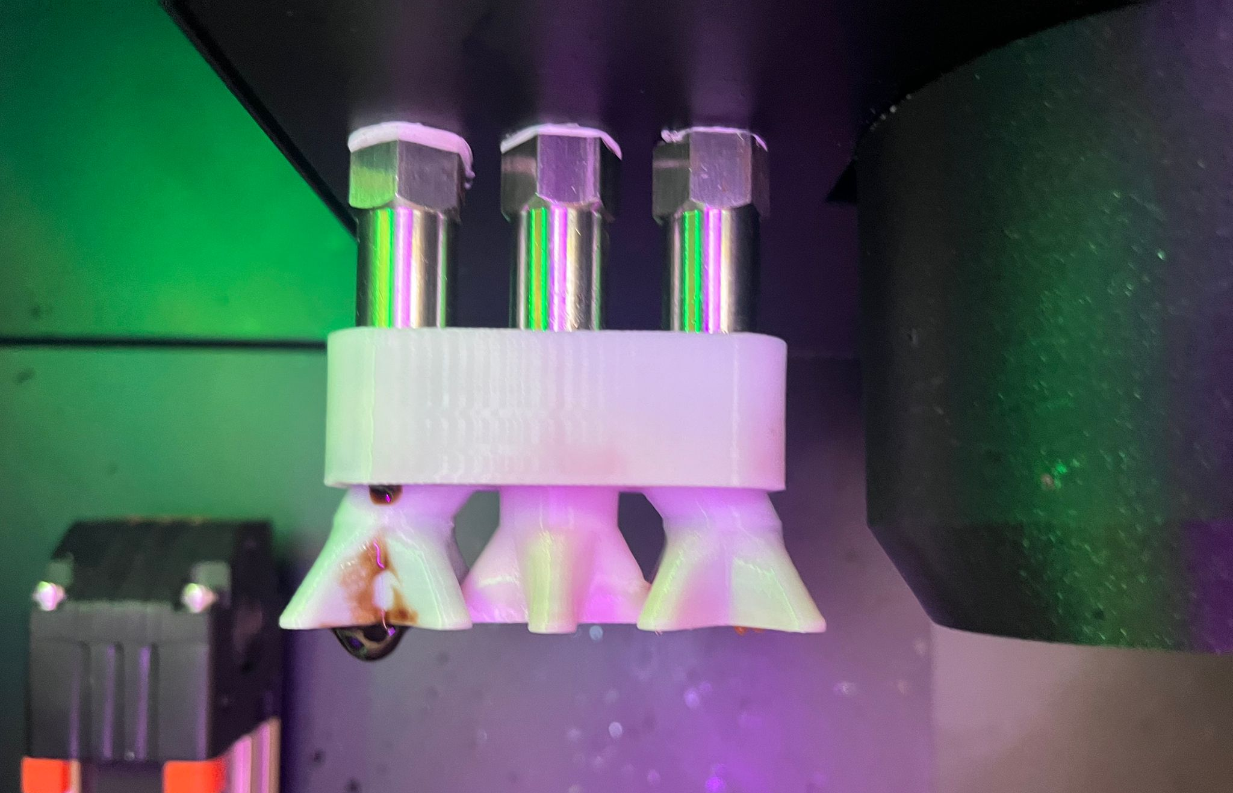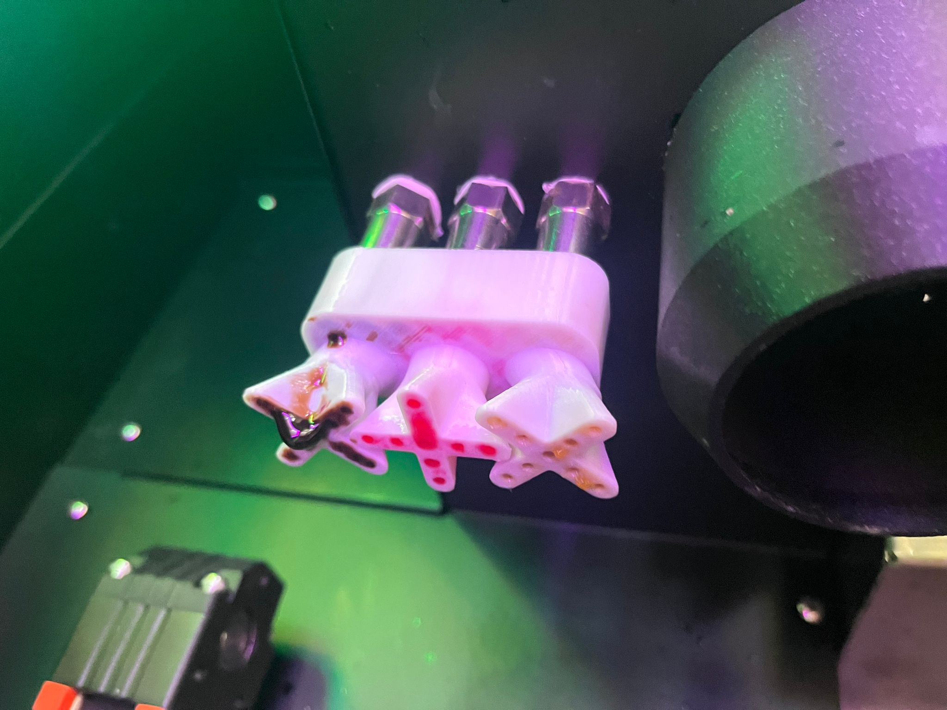

**Move LCD to hinge on side to be out of the way of ice cream hopper**

If there is an LCD used inside the machine then it should not block the hopper or toppings in any way. This LCD is in the middle of the machine and makes it hard for owners to Fill hopper(s), Toppings and Syrups. It should be Placed on the side wall with a hinge to allow it to swing out when in use. There should also be locks so you can lock in place for using and for storage on the wall.

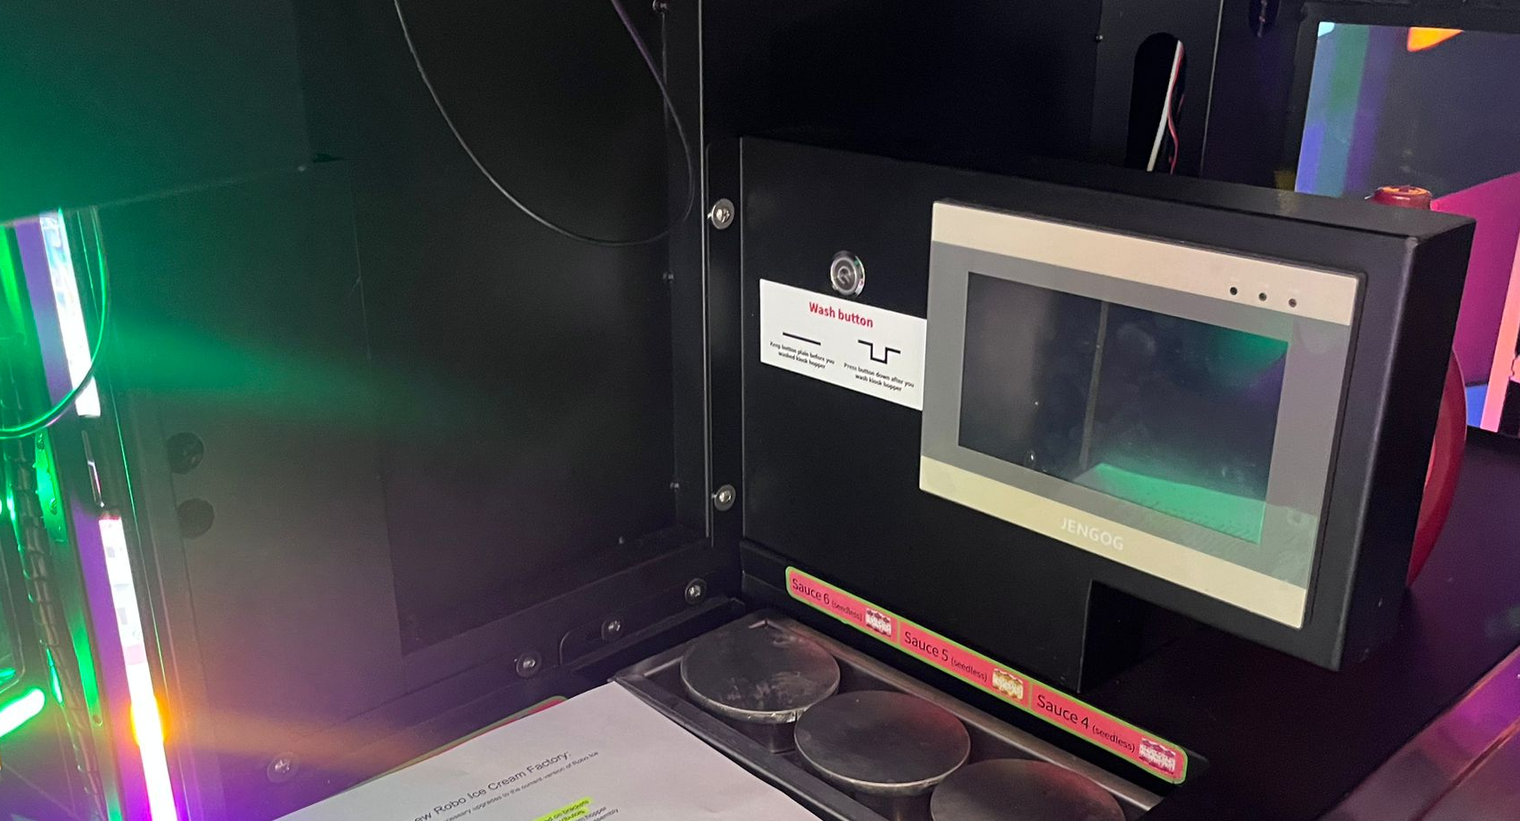

**Reduce weight of overhead sign, labelled with instructions for assembly**

The current sign on Roof is too heavy. The weight should be reduced to allow easy install and repair. Also the roof should be labelled on each edge to allow for EASY BUILDING for customers. Such as SIDE B goes to SIDE B (Wire A to Wire A)

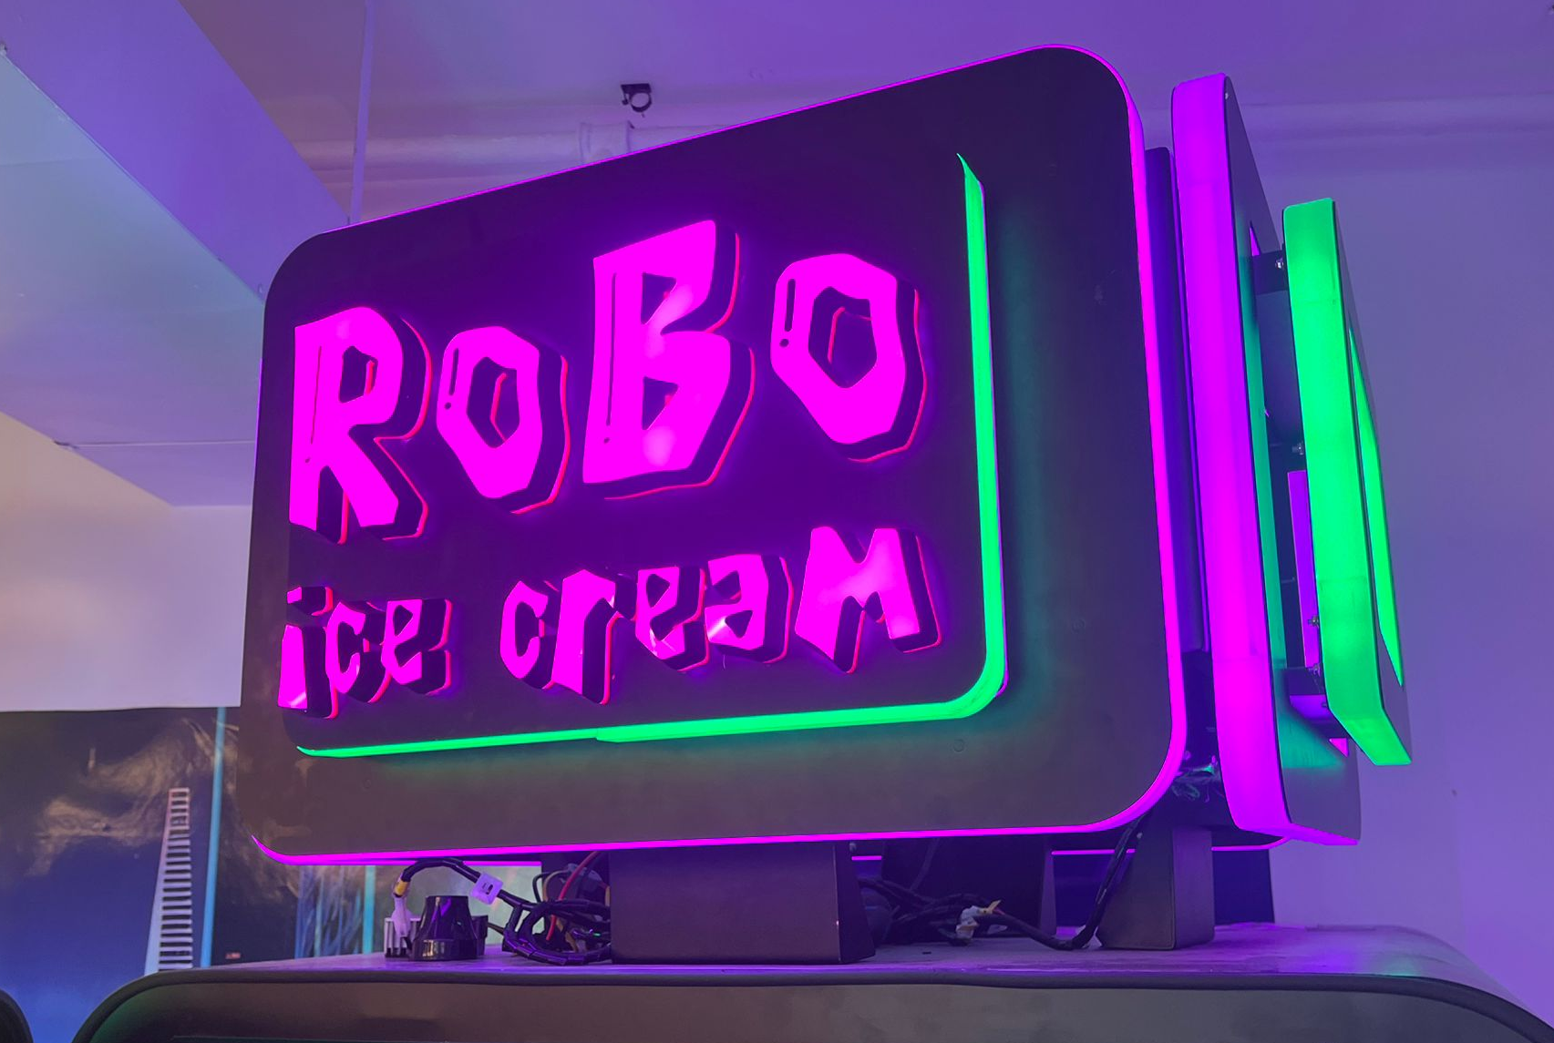

**Voltage stabilizer for stable power**

The machine should include a device that stabalizes the input power. We have noticed when the power isn't stabilized it may cause the machine to over work and give various errors.

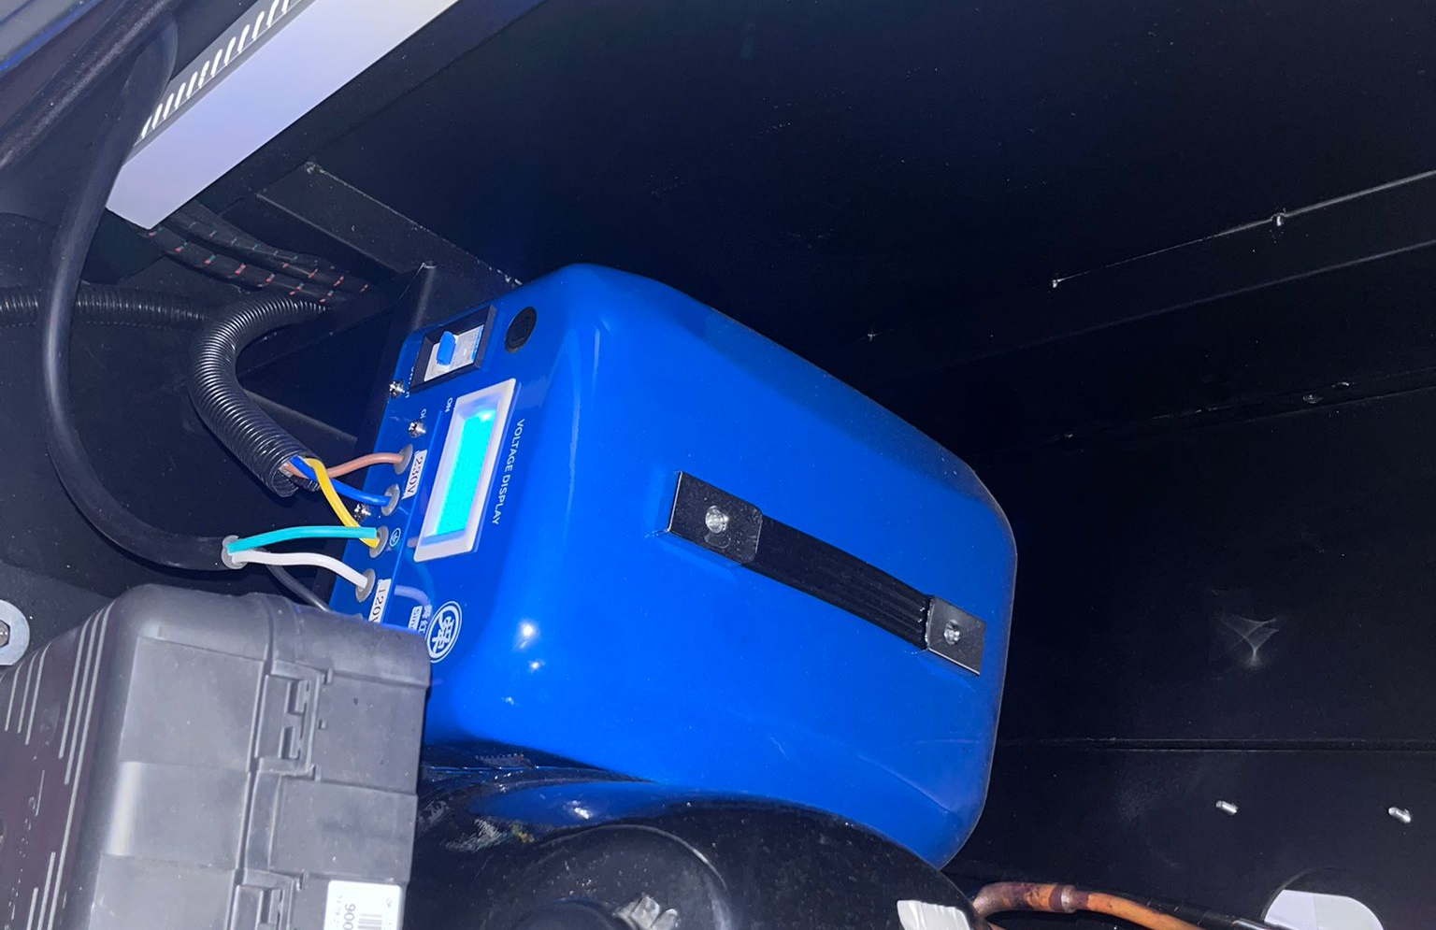

**Wall to prevent hands reaching in pickup area**

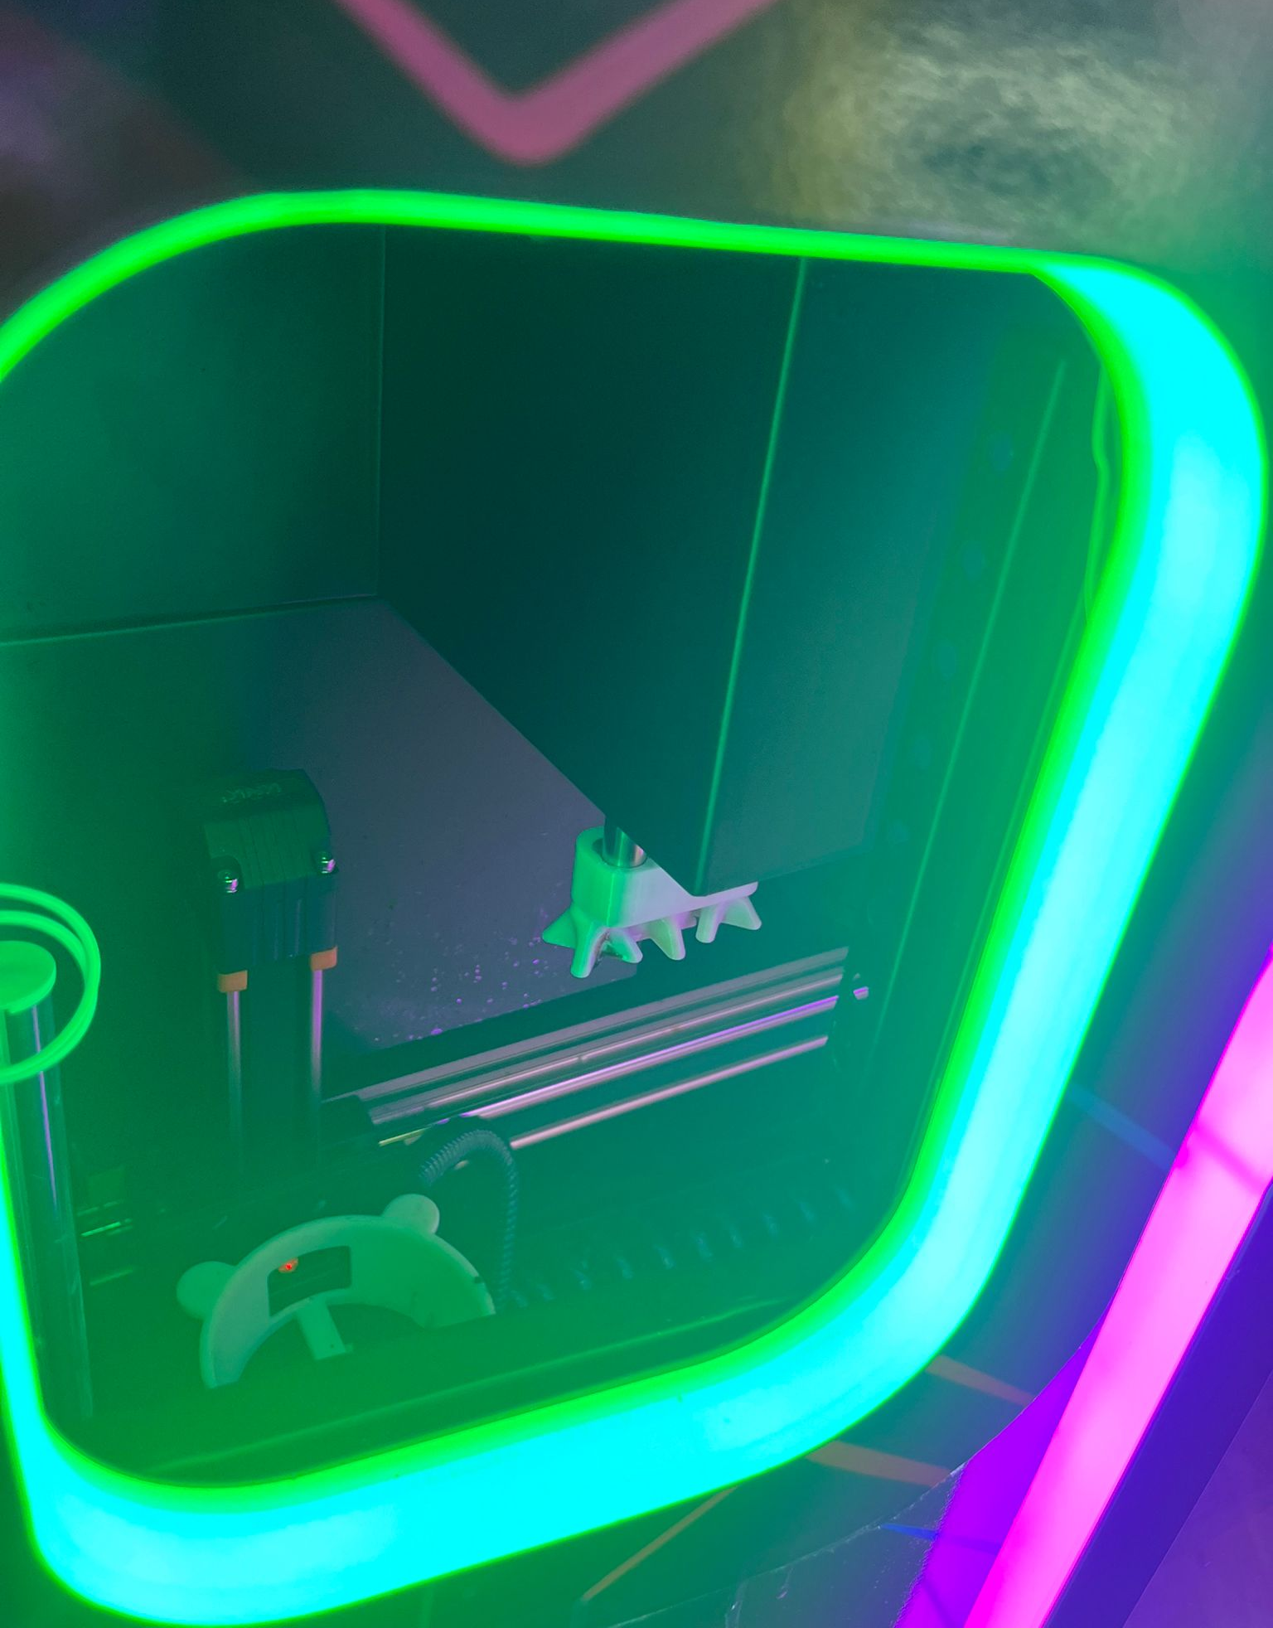

There should be a wall behind the opened door and ice cream to prevent a customer from reaching any place further than the actual ice cream in the pickup area.

**Properly rated power cable**

The power cable should be properly rated. Machines that use over 15A @ 120v should be using the correct cable for it. **A machine that uses 25A should not be using a 15A cable!!**

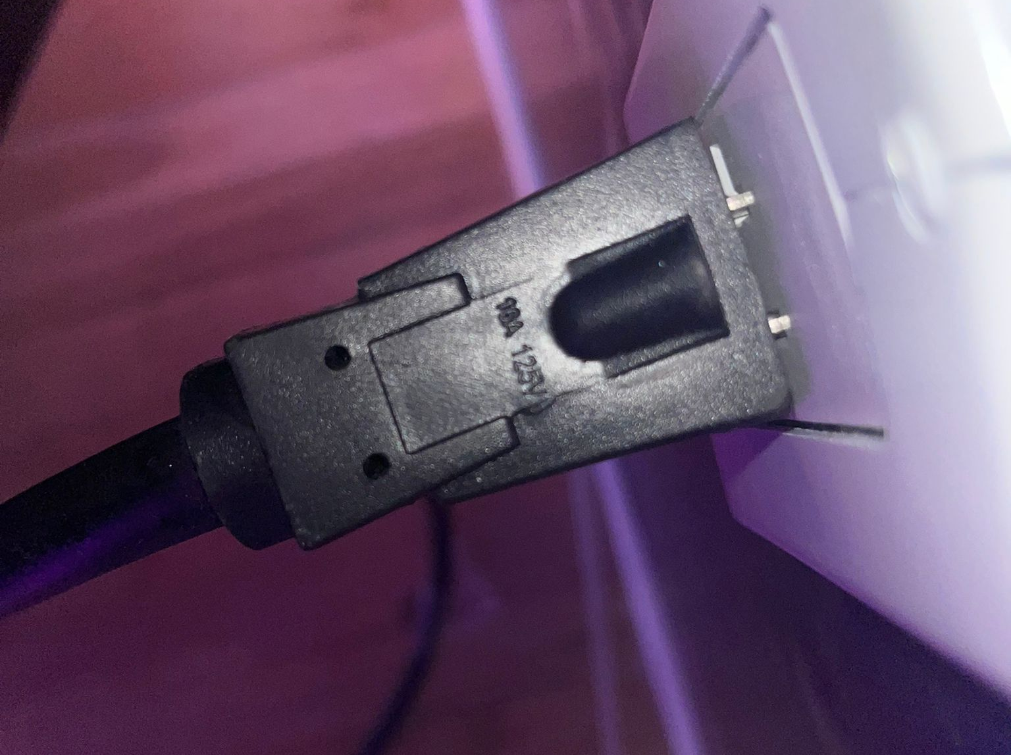

**Topping spreader**

We have designed a topping spreader that we would like to use in the machine. We can provide the STEP file for this.

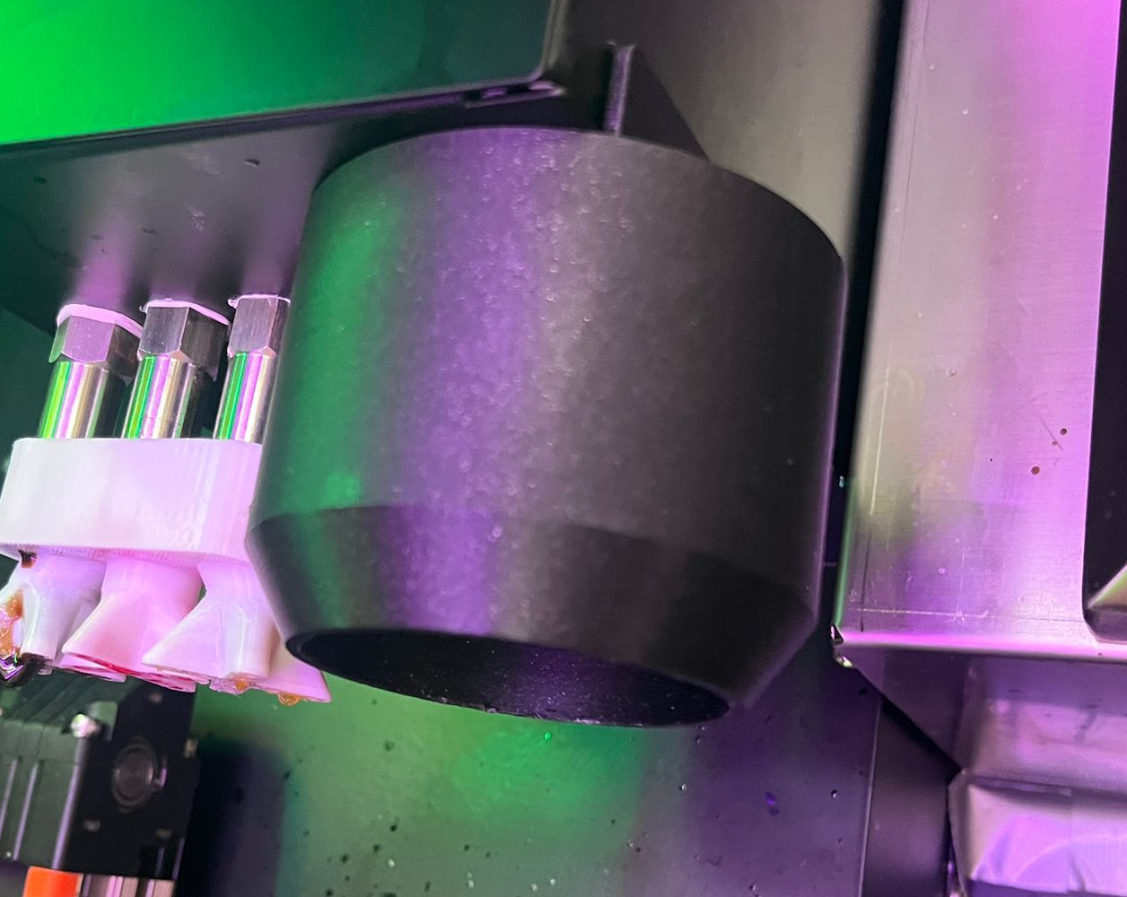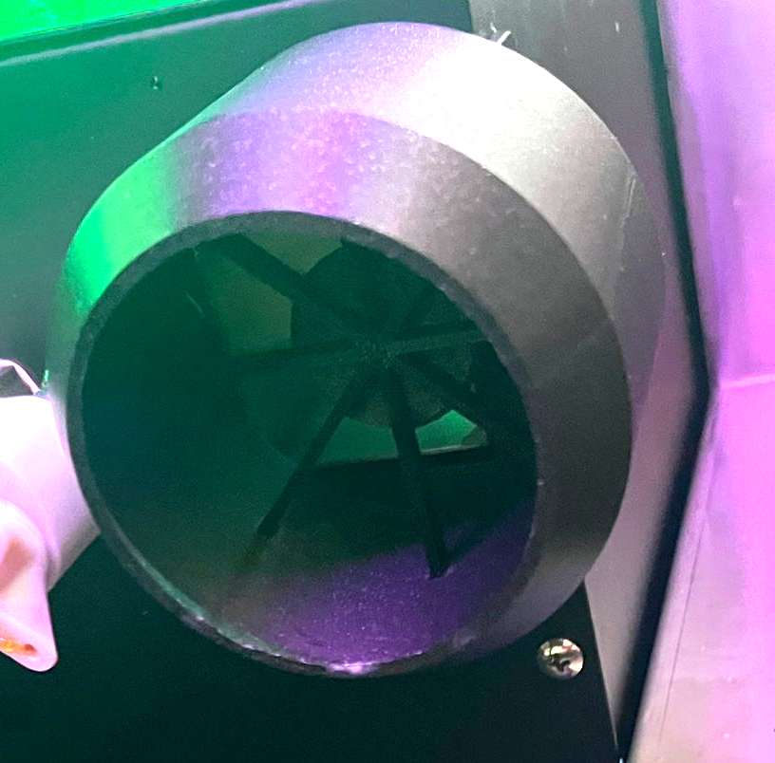

**Better connectors for entire machine - current ones burn up**

The current machine has connectors that fail often and over heat. This is due to bad contacts causing arcing. This causes power issues and cable failure. Please use properly rated connectors

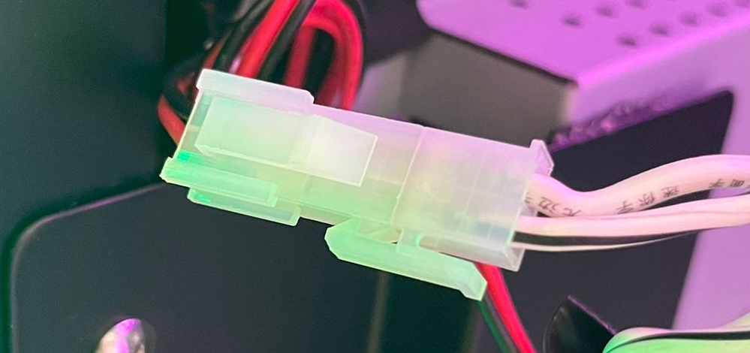

**DO NOT USE THESE**

**Switch for roof LEDs instead of software control**

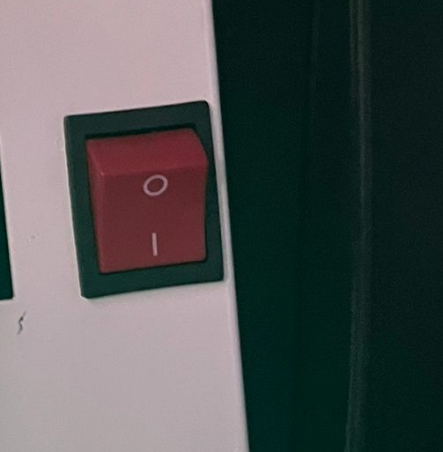

There should be a switch to manually control Roof Lighting and other External Lighting. These should not be controlled in software.

## Software

The software of the machine is one of the most important aspects of its operation. Please ensure the look and feel and operation of the software is smooth. There should be no ticking, freezing or having to DOUBLE TAP anywhere. Any Errors should only be displayed once and clearable from front or backend. A log of these errors should be kept and time stamped with any other information that made be needed to repair and prevent them from recurring.

The software should be updatable from our backend, this is very important.

Below are images of the look and feel of operation of the machine. There may be notes tied to these images so please read them carefully.

**Main Screen**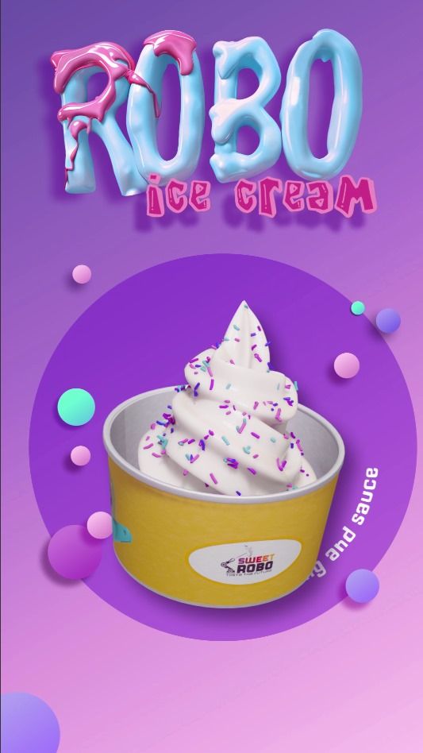

The start screen is an animation created by us. This screen is used as a basic advertisement. The screen should be changeable from the settings menu which will be noted in later images.

The animation should be a video (mp4), **NOT GIF**.

**Main Info Screen**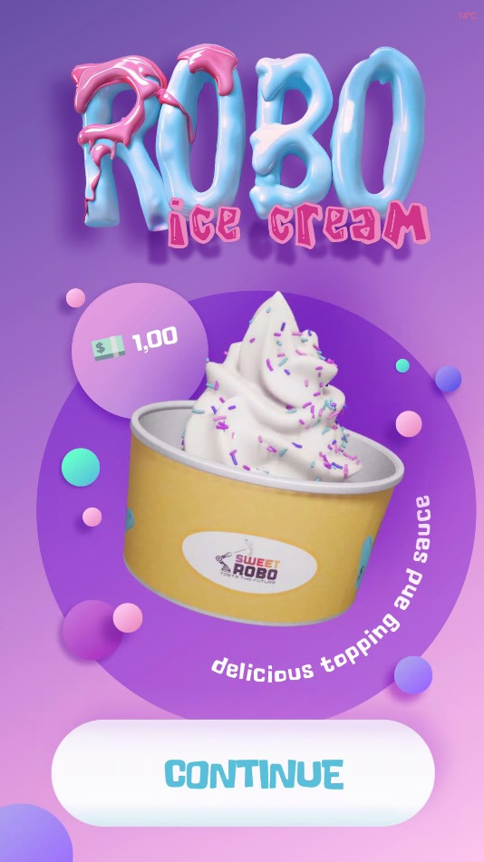

This screen comes right after the animation and is used to show customers the base price and flavor of the ice cream. If the customer is satisfied with these they will press continue.

**Toppings and Syrups**

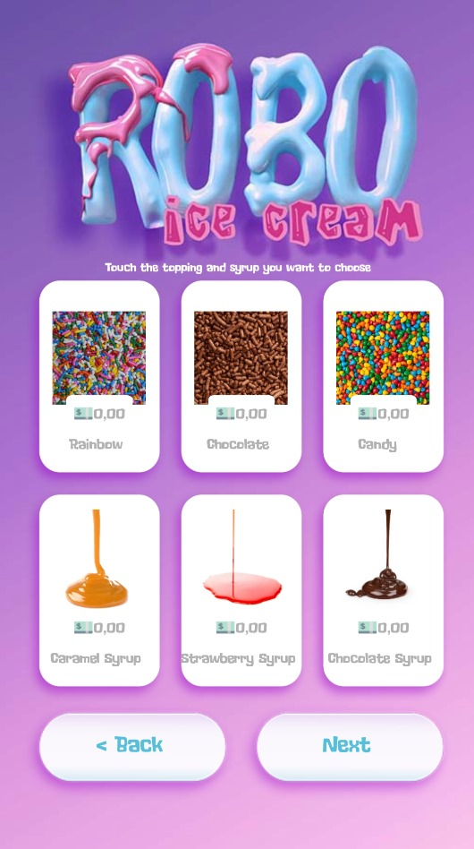

Once they press continue they are presented with this screen which allows them to add on Toppings and/or Syrups to their base ice cream.

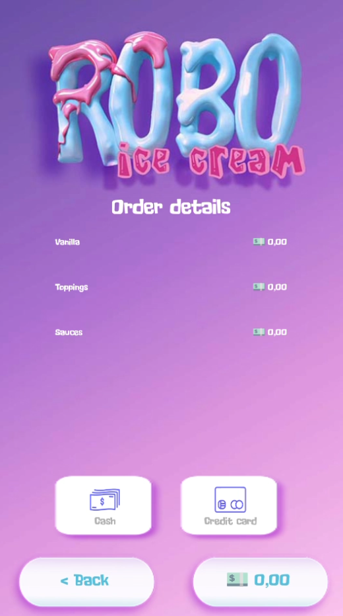

**The Last screen should show payment options and allow the customer to make a purchase.**

**Internal Software (Android Back End)**

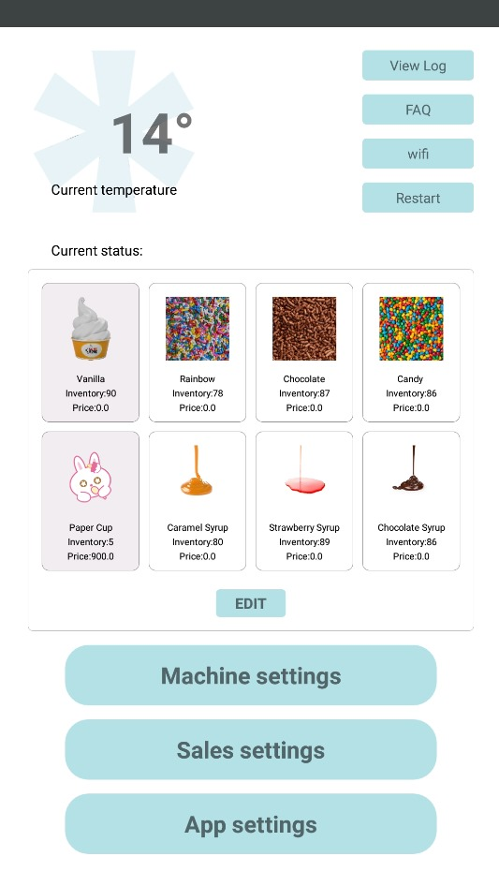

This is the main menu when entering the android backend and should allow a few things.

Log Access - Used for tech support

FAQ - For simple information to help owner

Wifi - Allow machine to connect to internet

Restart - Manually restart the software

Edit - Allow us to enter another page to change details on the product and machine.

Machine Settings - Allows users to alter the settings of the machine control.

Sale Settings - Allows users to keep track of sales and change payment settings.

App Settings - allows users to change settings for the app such as volume and access android settings.

**Edit**

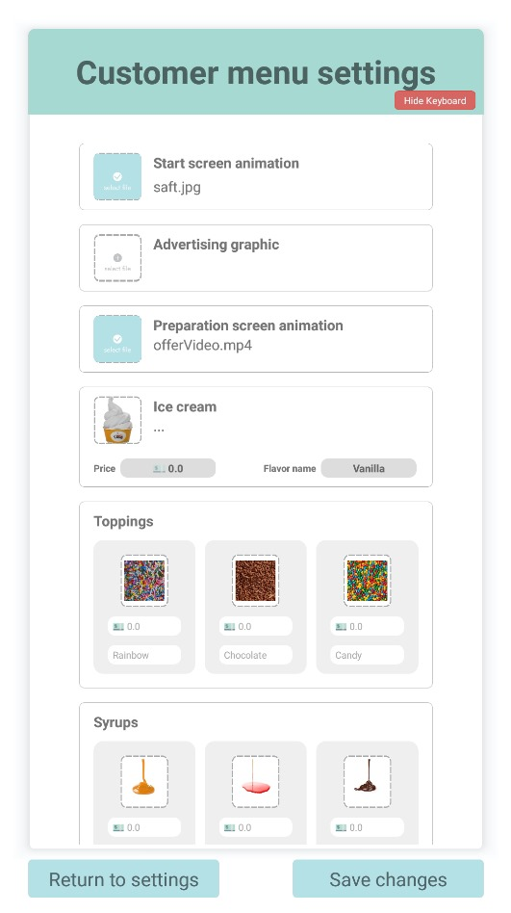

This is the EDIT menu, allowing you to edit a few details about all products sold and machine appearance.

* Start Animation Changing
* Advertisement Image  
   (2nd screen)
* Video when Ice Cream is  
   being produced
* Ice Cream Image, Price  
   and Flavor Name
* Toppings (Image, Name  
   and Price)
* Syrups (Image, Name and  
   Price)

**Machine Settings**

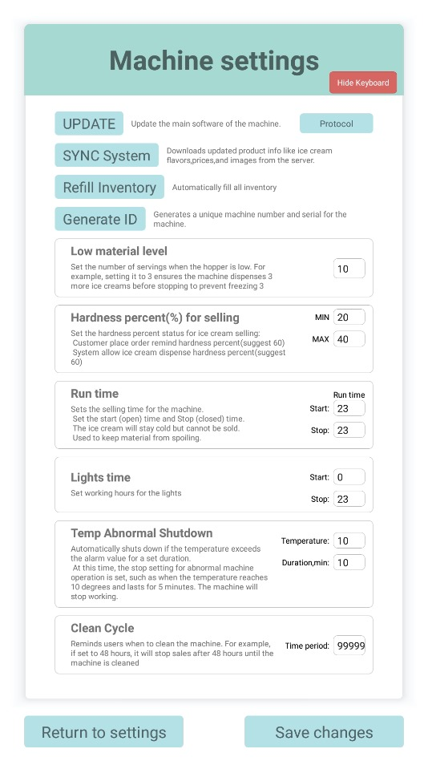

**UPDATE** - Used to manually check and update the software for ice cream. (this app)

**Sync** - used if our team has made any changes to products on our backend and the customer needs to sync it to their machine.

**Refill inventory** - Refills all stock levels to their maximum

**Generate ID** - used internally to generate a machine ir and serial.

**Low Material Level** - This is used to specify what is the max amount of servings to sell when the low level float switch is triggered. This is the amount of ice cream still in the center chamber.

**Hardness Percent** - This allows the customers to be able to purchase when the hardness percentage level has been reached.

**Runtime** - Hour of day to allow purchasing ice cream. 24-24 means 24hr sales operation.

**Lights Time** - NOT USED

**Temp Abnormal Shutdown -** If the temperature of the ice cream is held at a high temperature for longer than this time then it is no good and do not allow sales, shut down!

**Clean Cycle**

Owners should clean the machine about every 2-3 days so that's 48-72 hours. They should set this as a reminder alarm to stop sales and clean the machine.

**Sales Settings**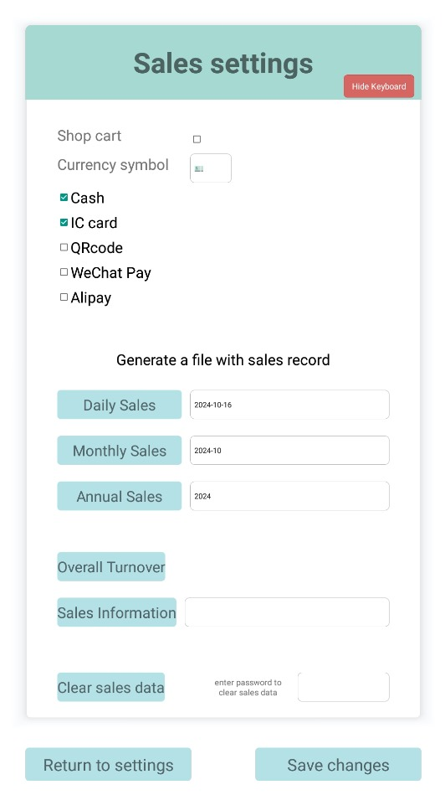

This is the sales settings page. It should allow customers to change various settings for selling and get information on sales.

**Currency Symbol** - Depending on the location of the machine this is the currency symbol used in that country.

**Devices** - Enable or disable different payment devices.

Various Sales fields to obtain sales information from device.

**App Settings**

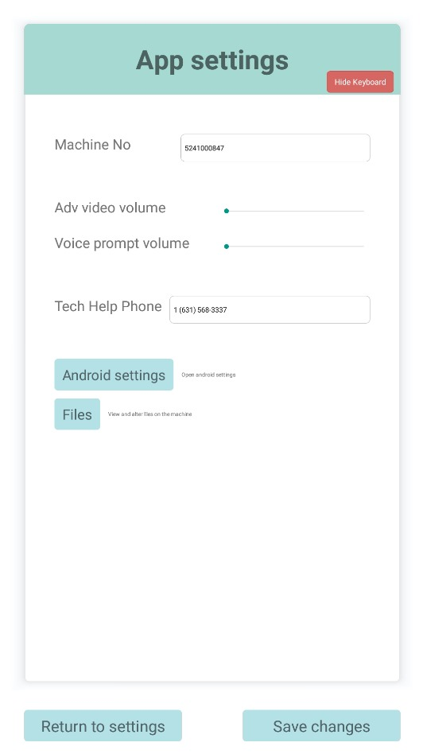

**Machine Number** - Customer number of machine, Not Editable

Volume for purchases and advertisements

Telephone number to be displayed for errors or issues.

Android Settings - Self Explanatory

Files - File Browser